DWBI Assignment 2

IT16032316

So First we should Load all the data to the Fact table Using the Dimensions and the Staging Area tables.

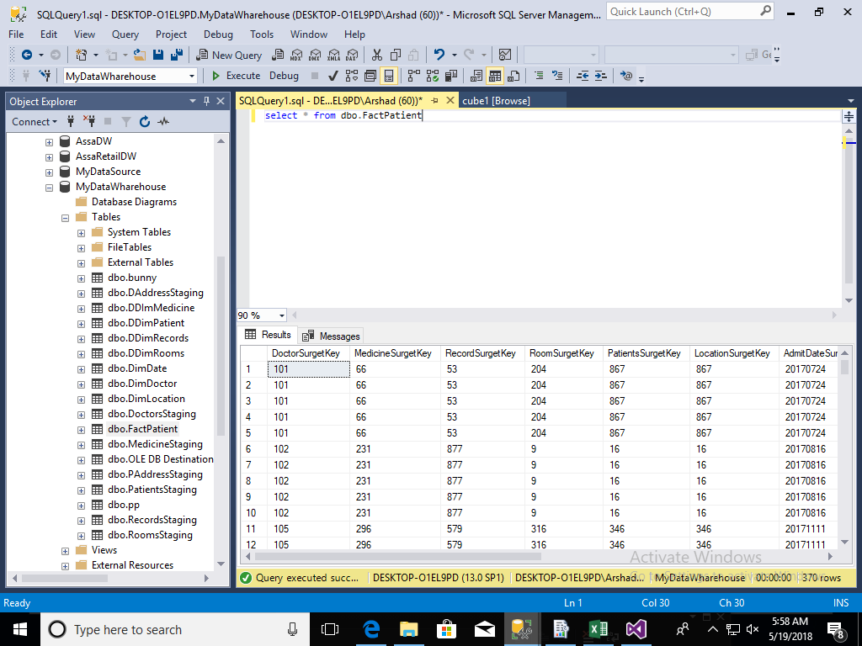

Making Cube

After Loading the Data into Fact Table I started to make cubes. First I enter all the important measures from Fact and dimension Table. I took Below dimension to make a cube for my analysis

* DimPatients
* DimDoctor
* DimLocation
* DimDate
* DimMedicine

29+i

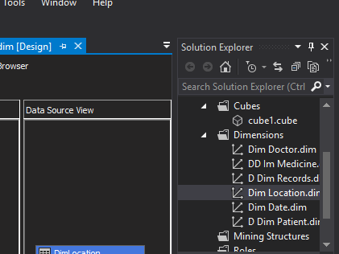

After Loading this Data the cube Structure Look like below

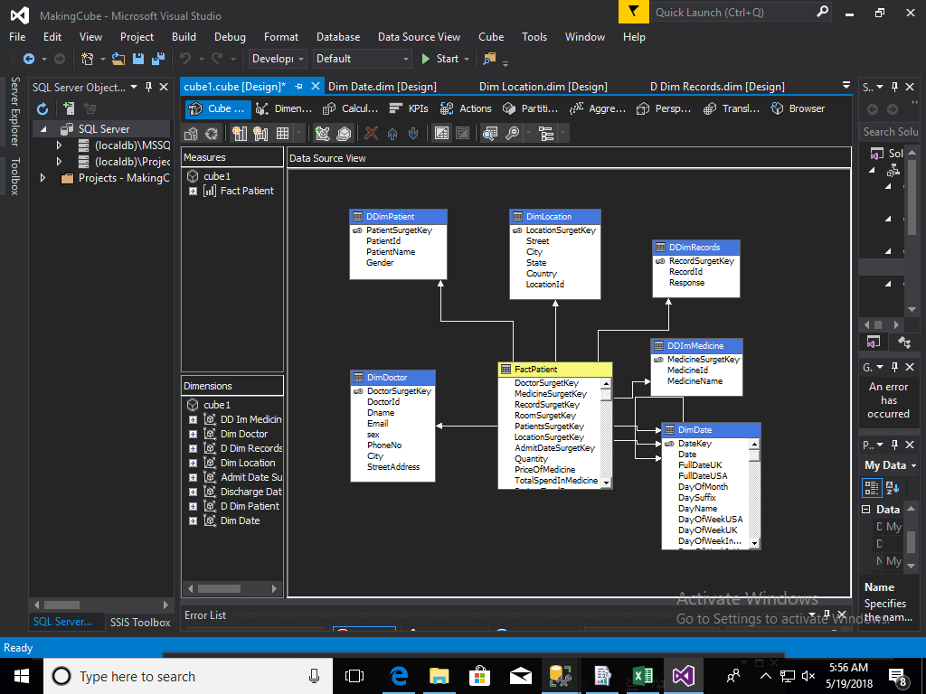

Then I Deployed the cube to the Sql Then the structure Look like below

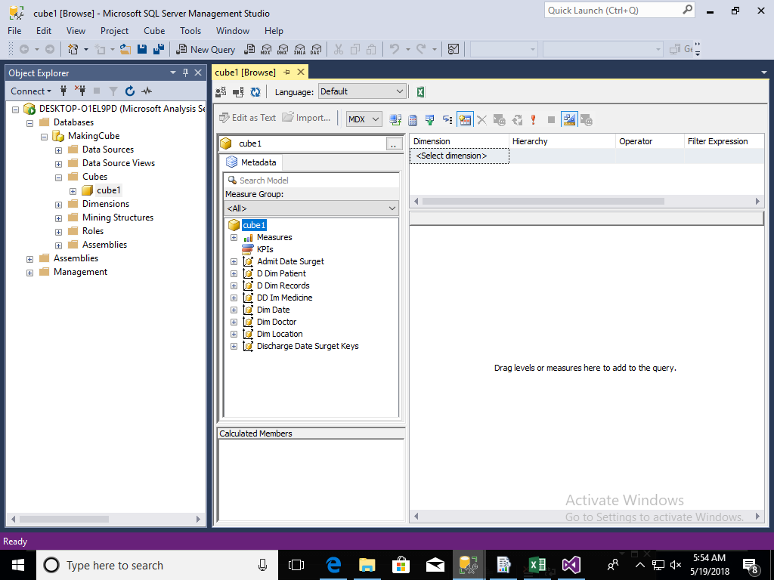

I also implemented A hierarchy for Location which follow this below path

Country->State->City->Street

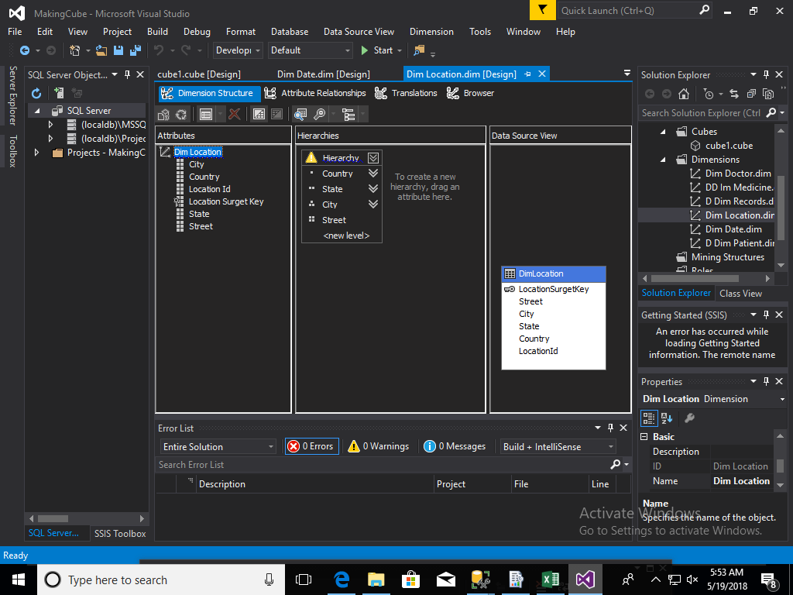

Reports

1.Matrix Report

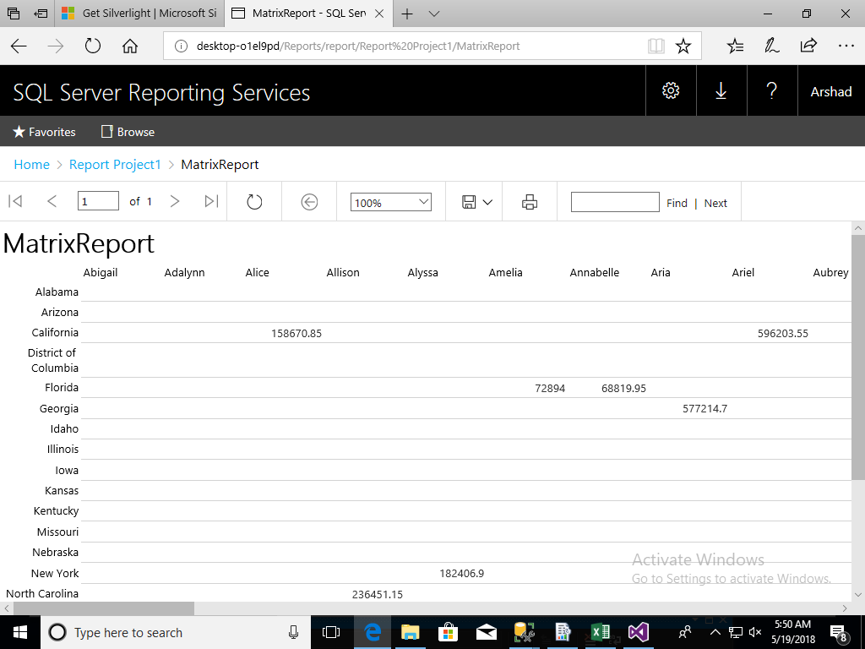

This Report is to view all the Total payment Paid by the which Patient from which State of the Country. So took the patient name and the State of the Patient to view this data.

2.DrillDown OR Drill Through

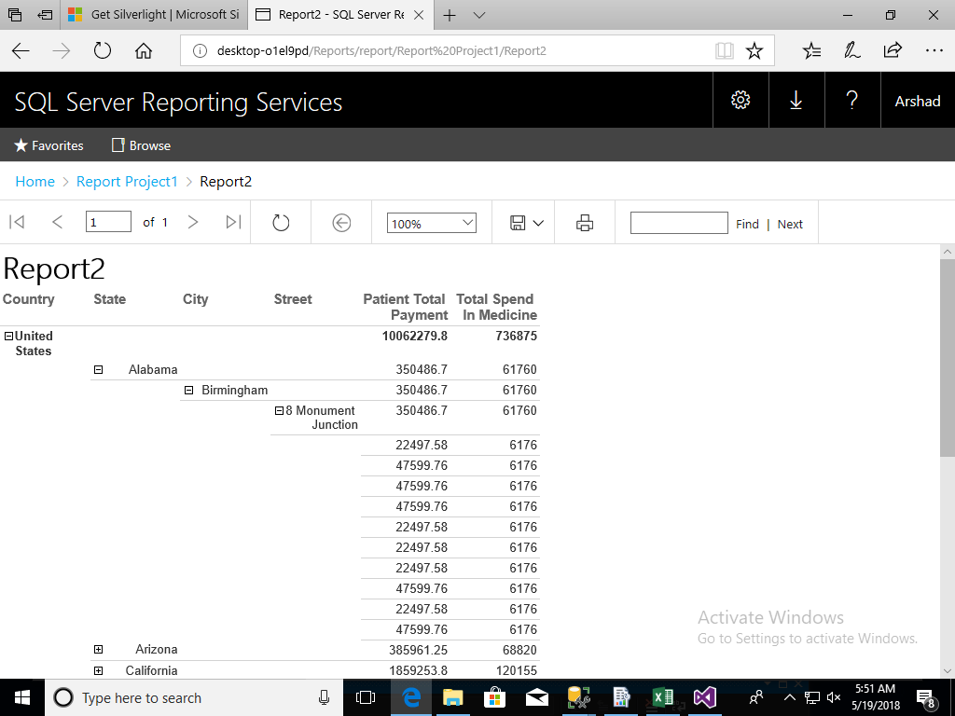

This Report is to View from which country which state which city what is the total

Payment of the patient.so here we are maintaining a hierarchy Structure to drill down or drill through

3.Parameterized Report

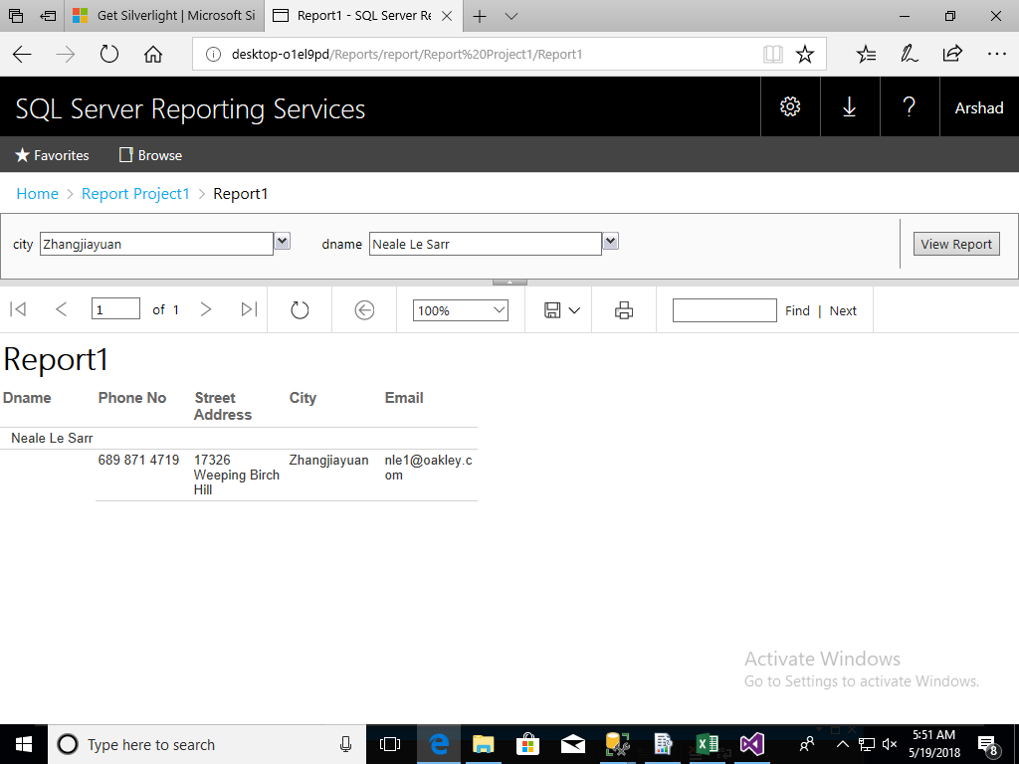

Here we are passing 2 parameters to get the Data of a Doctor.so here we are searching a city and it will get the Doctor Who belong to that city and it will display and generate the report of that doctor

Demonstration of OLAP operations

1.Drilldown and Rollup

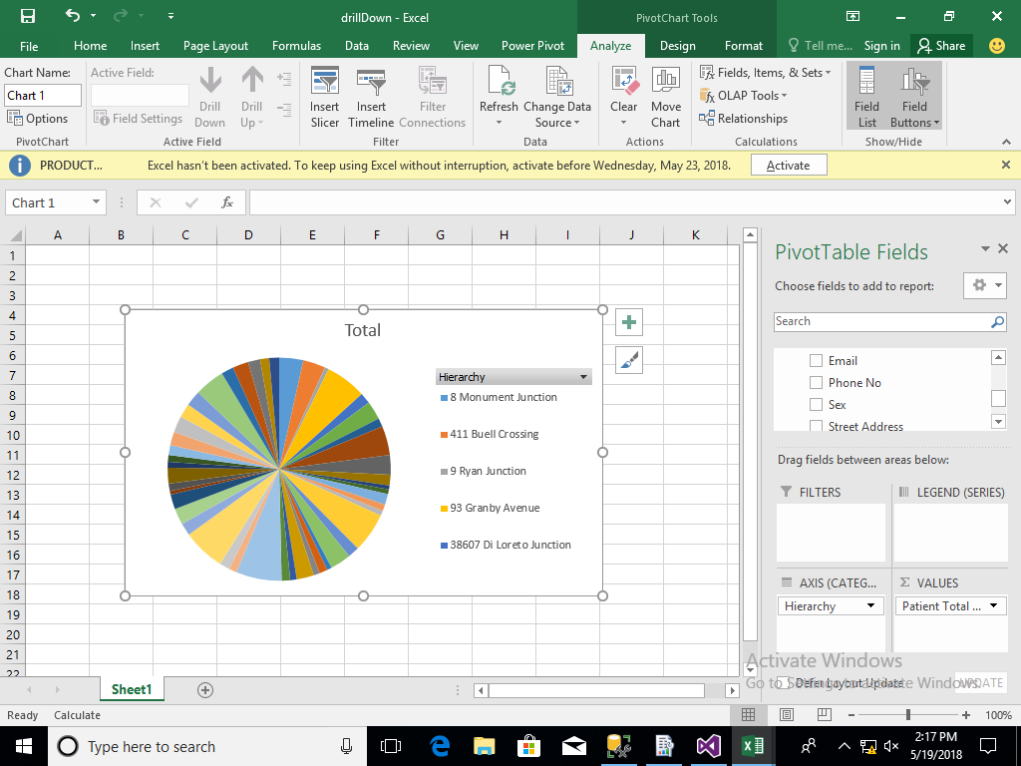

This Drilldown and Rollup purpose I used location hierarchy and Drill down from Country to Street Then Roll up from city to country.

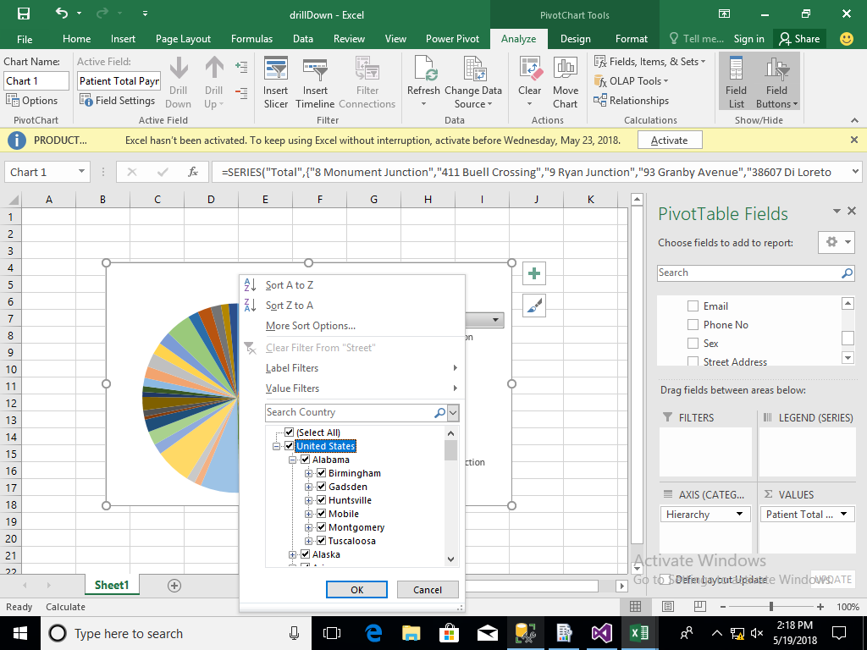

2.Pivot

This is like changing the columns so Added some of the fields of the table and done the pivot operation

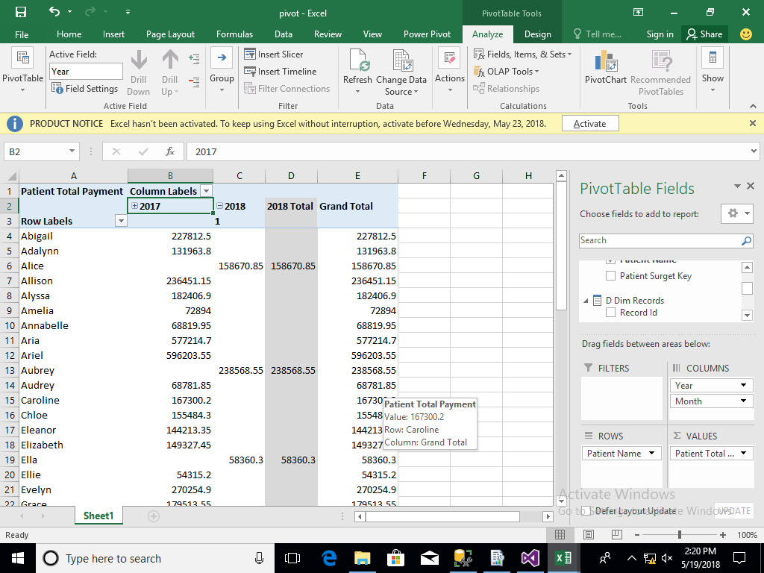

3.Slicing

I used the patient discharge date and slice through which patient leave form hospital and how much of amount he paid for that .

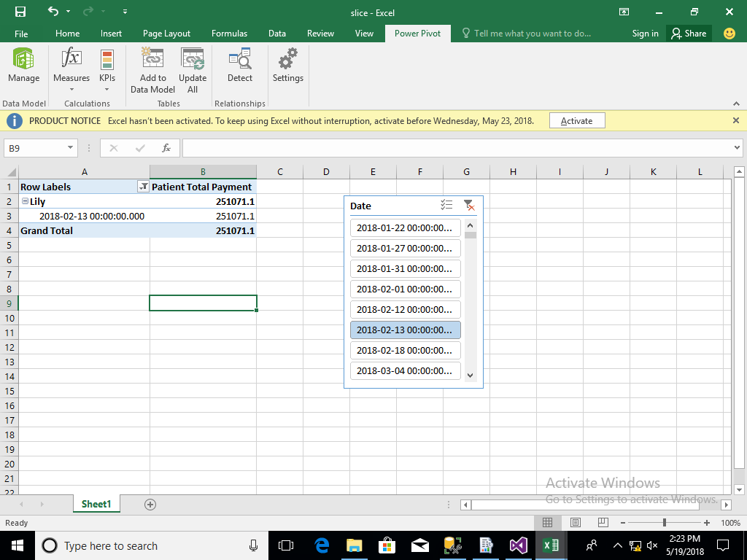

DrillThrough

